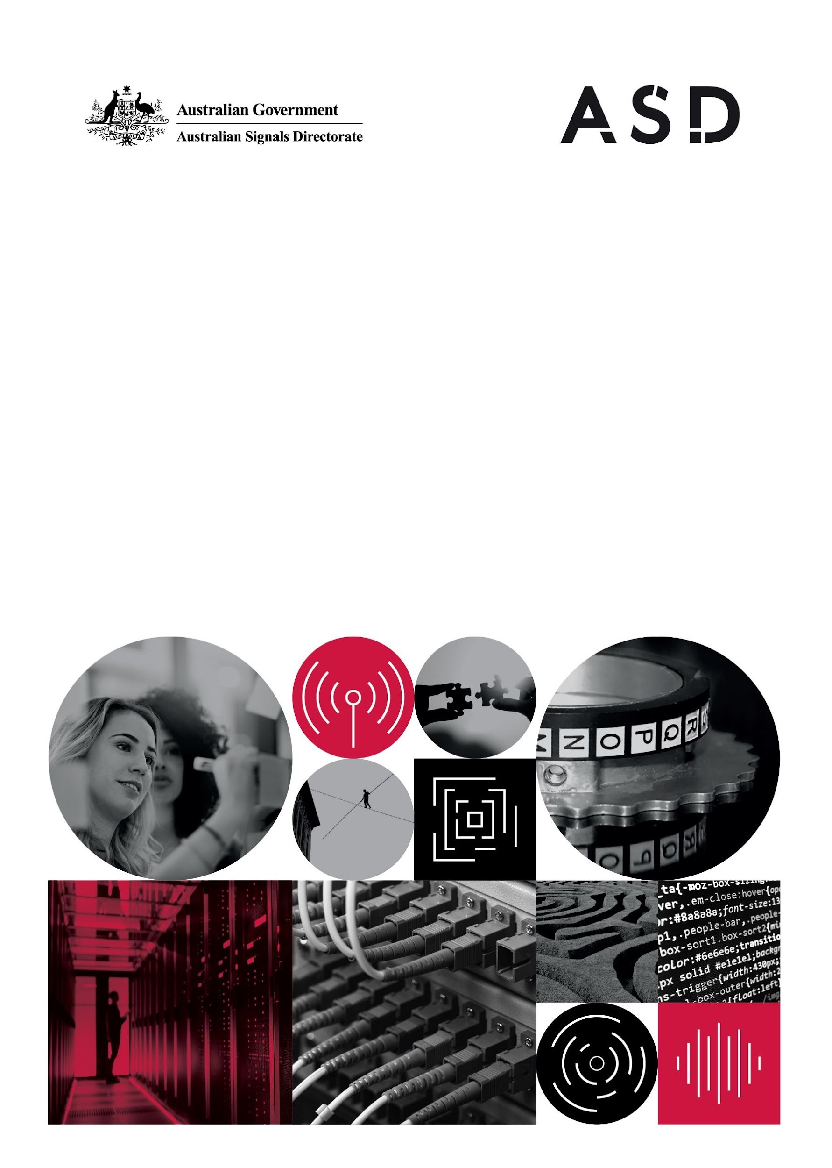 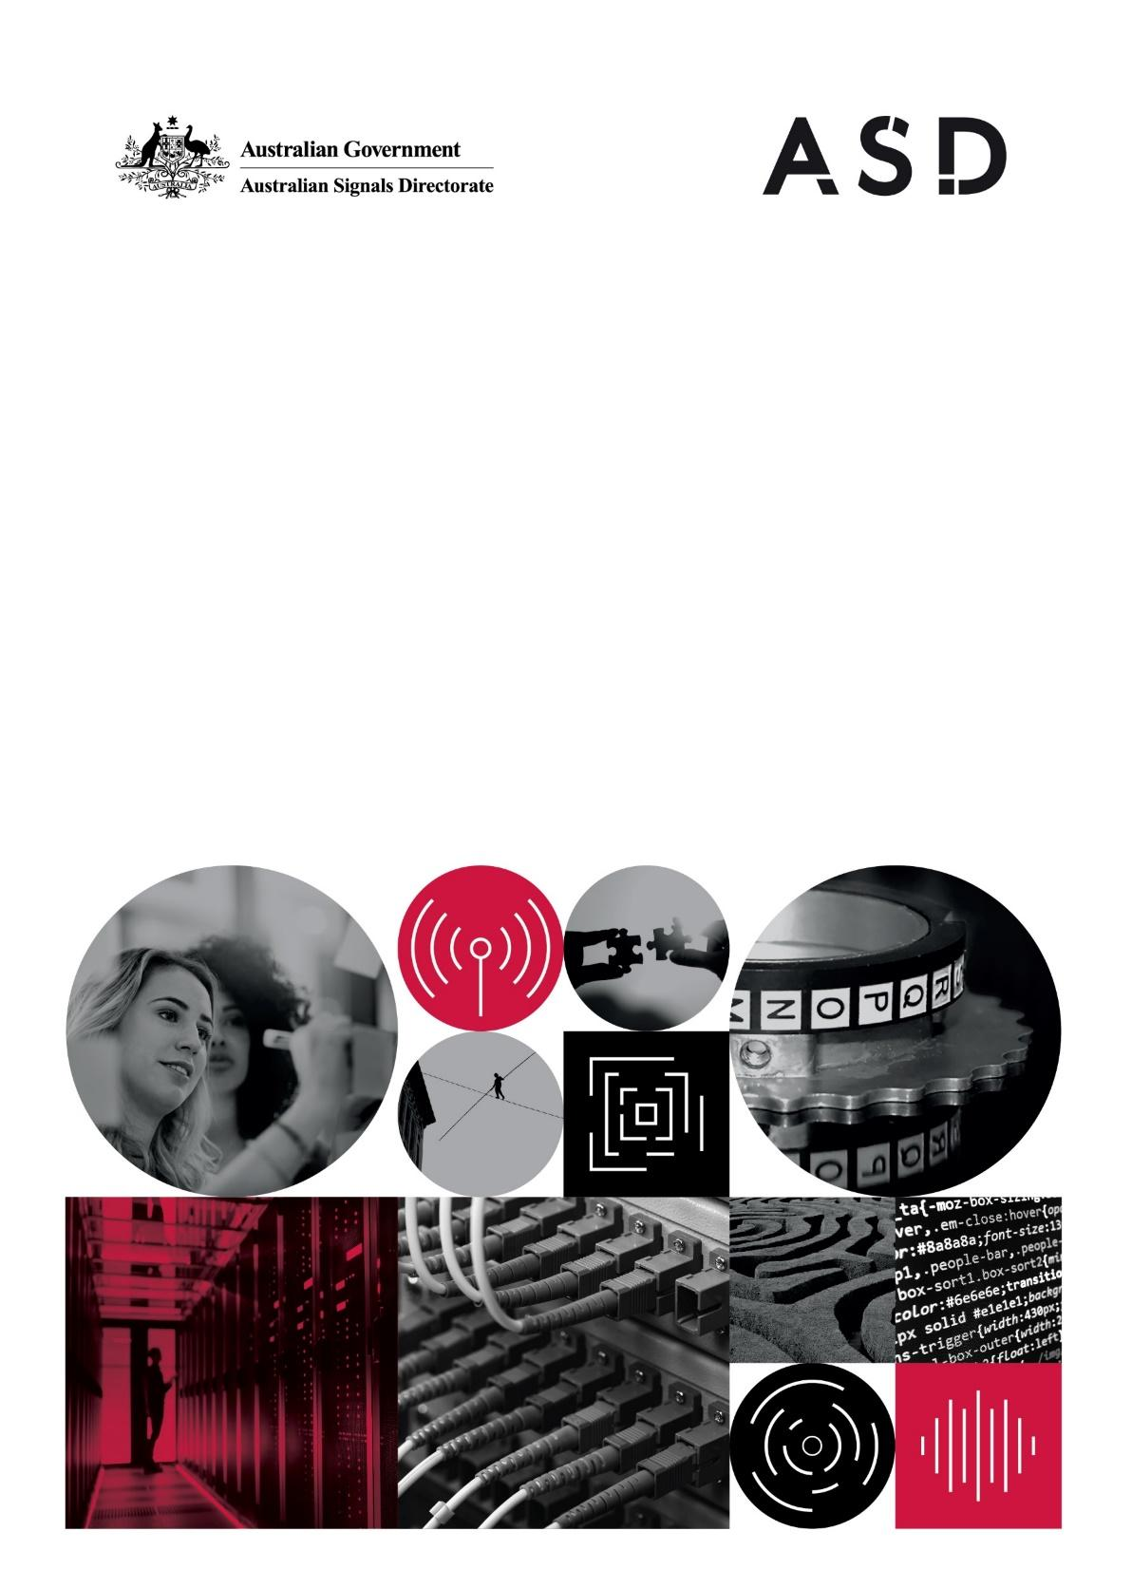



**I N F O R M A T I O N P A C K**

|  |  |
| --- | --- |
| **Position Title:** | **ASD 4, 5, 6 Software Developer** |
| **Job Reference Number:** | ASD/10038/23 |
| **ASD Level:** | ASD4, ASD5, ASD 6 |
| **Location:** | Canberra, ACT; Brisbane, QLD; Melbourne, VIC; Perth, WA |
| **Total Salary Package*:** | **$77,787.84 - $147,915.36 (plus 15.4% super)**  *Total Salary Package is inclusive of a base salary of **$74,796.00 - $102,719.00**, 4% service allowance and skill payments (where eligible).  **Service Allowance:** Working for ASD as part of Australia’s intelligence community requires our employees to adopt security measures that go beyond many other Australian Public Service or Commonwealth employers. For that reason, ASD employees receive an additional allowance of 4% on top of substantive salary. This allowance is superannuable.  **Skill Payments:** Up to 40% loading on base salary ***may*** be applicable upon further assessment. Skills Payments count as salary for superannuation, though do not count as salary for the purpose of service allowance. |
| **Employment Status:** | Ongoing - Full time, Part time (hours negotiable), Flexible |
| **Security Clearance:** | Baseline to commence, with the ability to obtain and maintain Positive Vetting |
| **Group:** | Australian Signals Directorate |
| **Contact Officer:** | asdcareers@dfp.com.au |
| **Closing Date:** | **11:30pm (AEST), Sunday 29 October 2023**  **No extensions will be granted and late applications  will not be accepted.** |

**About the Australian Signals Directorate**

The Australian Signals Directorate (ASD) is a vital member of Australia’s national security community. We work across the full spectrum of operations required of contemporary signals intelligence and security agencies. This includes intelligence, cyber security and offensive cyber operations in support of the Australian Government and Australian Defence Force (ADF).

Our greatest asset is our people. No matter the technology, the problem or the task, we cannot accomplish our mission without them.

We seek to recruit and develop a diverse workforce who are curious, imaginative and not deterred by difficult challenges. These skills allow us to out-think and out-imagine some of the most testing adversaries and problems imaginable.

**Our People**

At ASD, we celebrate [Diversity and Inclusion](https://www.asd.gov.au/careers/working-asd/diversity-and-inclusion). Diversity powers ASD's mission and we are committed to building an inclusive workplace, where all employees feel safe to bring their whole selves to work.

We take conscious action towards reconciliation and ASD has a strong cohort of Aboriginal and Torres Strait Islander employees. Our flexible work options are an important benefit for all our people and enable the many carers at ASD to balance their work and home responsibilities. We have a wide range of reasonable adjustments that can be made in the workplace, which is beneficial to all staff and particularly important for our ASD colleagues who are nuerodiverse or have a disability.

The [RecruitAbility](https://www.apsc.gov.au/working-aps/diversity-and-inclusion/disability/recruitability/recruitability-scheme-guide-applicants) scheme applies to all ASD vacancies, which encourages the employment of people with a disability. You will be asked to indicate if you wish to opt into the RecruitAbility scheme in the Diversity section of the application form. You must tick the ‘opt in’ box in order to participate in the scheme.

Please inform the Contact Officer if you require any reasonable adjustments.

**About the Team**

ASD is entering an exciting phase of growth, innovation and transformation. Our agency has committed to delivering [REDSPICE](https://www.asd.gov.au/sites/default/files/2022-05/ASD-REDSPICE-Blueprint.pdf), which is the most significant single investment in the Australian Signals Directorate’s 75 years.

If you answer yes to any of the below questions, keep reading, we want your skills!

* Would you like to develop, build and deliver world class software to protect Australia and its national interests?
* Can you be counted on to find innovative, clever solutions and develop your skills to become a well-rounded software engineer?
* Are you interested in achieving things most people never get a chance to?
* Are you driven to figure out why your computer crashed instead of just rebooting it?
* Do you enjoy connecting/integrating data systems and improving automation?

**About the Roles**

We have a range of exciting, challenging and interesting work for software developers across all groups in ASD. We are seeking people who want to be at the forefront of innovation and want to work alongside experts in a wide variety of fields. ASD provide opportunities to enhance your skills through mentoring and extensive training, and staff are encouraged to help directly shape your own technical and professional development.

ASD has a wide variety of Software Developer roles on offer. You may play a pivotal role in:

* Developing and ensuring the critical capabilities used by our workforce are fit-for-purpose, responsive to sensitive and time-critical mission requirements, and built on technology stacks in line with industry advances.
* Designing and building tools for AI/ML/Big Data developing systems that extract knowledge and insights from data to achieve ASD’s diverse mission objectives.
* Development of the platforms used by the Australia Cyber Security Centre to inform and interact with its stakeholders that range from individuals through to large organisations and government agencies.

ASD’s software developers typically work in multi-disciplinary teams responsible for the design and development of capabilities that meet ASD’s mission needs. Teams will work on a combination of long term projects as well as providing time sensitive development and support when required. The tools, platforms, technologies and methodologies used are extremely varied, but most have a strong emphasis on Agile or DevOps practices to achieve this.

**Ideal Candidate**

ASD is looking for software developers at all stages of their careers from people who have limited experience developing software through to people who have been designing large or complex capabilities for years. We encourage potential candidates with demonstrable programming experience to apply.

We are looking for people who can work under general direction to develop systems that work at scale with high bandwidth, large throughput systems. The ideal candidate will exercise good judgement, demonstrate initiative and have a focus on continuous improvement.

***ASD is seeking applicants to fill current and anticipated vacancies and to create a merit pool for future vacancies.***

**Mandatory Qualifications and Experience**

ASD 4 & 5 - Demonstrated proficiency with at least one programming language.

ASD 6 - Demonstrated expertise in developing, and proficiency architecting, with at least one programming language.

**Desirable Qualifications, Experience or Training**

ASD is seeking candidates with a wide and diverse set of software development expertise. You will need to demonstrate your level of skills and experience in one or more of the following areas:

* Experience in web development (full-stack developers)
* UI/UX front-end (React, Angular Frameworks etc) and (CSS, HTML etc.)
* Database design (Oracle SQL, relational database schemas)
* Git version control, CI/CD pipelines, code quality reviews (SonarQube)
* Kubernetes, HELM, Cloud deployments
* Mock-ups and wireframing
* Generating project artefacts (product documentation)
* Scrum and Kanban Agile team experience
* Low level and high level languages and ETL processes such as C, Rust, Assembly, Golang, Python and other embedded development languages.
* Backend (Java, Spring boot, Spring Cloud, API (Swagger), Maven, Django (Python), authentication (KeyCloak), logging and audit

**How to Apply**

**Application**

Applications must be submitted through the [ASD Careers](https://defencecareers.nga.net.au/cp/index.cfm?event=jobs.home&CurATC=ASDEXT&CurBID=C49A927D-AAE1-A68D-E047-B5FED76E0B7B&persistVariables=CurATC%2CCurBID) page on our website. For further information on how to submit an online application, please refer to the [Applicant User Guide](https://www1.defence.gov.au/sites/default/files/2020-10/Applicant-User-Guide.pdf).

**NOTE: This is an UNCLASSIFIED recruitment activity.** **You should be mindful that all information contained in your application must be OFFICIAL only.**

Applications containing classified information will not be considered by the Selection Delegate. Refer to the [Australian Government’s Security Policy Framework](https://www.protectivesecurity.gov.au/sites/default/files/PSPF-fact-sheet-classification-reforms.pdf) to assess if the information you are providing is sensitive or security classified.

**Written Response**

When forming your response, you should consider the position description and provide examples which demonstrate your ability to perform the duties of the role.

Applicants are required to provide a response addressing the following:

1. Examples of relevant experience, qualities and skills that you will bring to the role (limit your total response to 600 words).

**Referees**

You will be required to include the names and contact details of two referees who can comment on your work performance. One of these referees must be your current supervisor or manager. Please advise in your application if you do not want us to contact your referees without advising you first.

ASD uses the equivalent APS-wide Work Level Standards as the foundation of approved classifications in our employment framework. Candidates are encouraged to refer to the work level standards when determining which ASD classification best aligns with their skills, knowledge and experience. Additional information about APS classifications is available on the [Australian Public Service Commission website](https://www.apsc.gov.au/work-level-standards-aps-level-and-executive-level-classifications).

ASD may utilise external recruitment service providers to administer a range of recruitment services, including online testing and reference checking. When you submit an application you are agreeing to have your personal details shared with these providers for ASD recruitment purposes.

Vacancies will be extended **in exceptional circumstances only**. Applicants requesting an extension **must** contact the Contact Officer **24 hours prior** to the vacancy closing date.

**Eligibility**

Please ensure that you meet the eligibility requirements outlined in this Information Pack prior to submitting an application.

**Citizenship** - To be eligible for employment with ASD, applicants must be an Australian citizen.

**Health Assessment** -The preferred applicant may be required to undergo a medical examination conducted by the Agency’s preferred medical provider.

**Organisational Suitability Assessment** – To be eligible for employment within ASD, the preferred applicant will be required to undergo an Organisational Suitability Assessment (see Organisational Assessment section).

**Security Clearance** - The preferred applicant will be required to successfully undergo the security clearance vetting process at a specified clearance level. The preferred applicant **MUST** be willing to disclose all relevant and required information.

It is a condition of employment that applicants are willing and able to obtain and maintain the requisite security clearance for the duration of their employment with ASD.

**Organisational Suitability Assessment**

An Organisational Suitability Assessment (OSA) is a mandatory requirement for   
work in ASD.

Organisational Suitability Assessments are conducted to determine suitability to work in a high security environment and/or to hold a Positive Vetting (PV) security clearance.

The assessment is administered in a manner which ensures informed consent, fair dealing with all applicants and employees, and the greatest possible degree of privacy and transparency of process. Before you submit an application you should consider your own preparedness for questions that may include the following topics: personal relationships, living circumstances, personal values, financial situation, physical and mental health history including substance use, and any civil and/or military record.

**Feedback**

If you are currently employed in the Australian Intelligence Community or the ADF, you will be provided with feedback on your Organisational Assessment if the outcome has an adverse bearing on your current employment. **No feedback** will be provided on the outcome of the assessment process to any other applicant.

**Employment Agreement**

**Terms of the Engagement**

The successful applicant for the position noted in this Information Pack will be engaged under the [*ASD Employment Determination 2020*](https://www.asd.gov.au/careers/working-asd/employment-conditions)*.*

**Remuneration Package**

In accordance with the [*ASD Employment Determination 2020*](https://www.asd.gov.au/careers/working-asd/employment-conditions) the successful candidate will receive an attractive remuneration package with a salary within the range noted on the front page of this Information Packand superannuation paid in accordance with legislative requirements.

**Further Information**

Please refer to our Careers Website for more information on our Employment Agreement, Remuneration Package, Eligibility Requirements, Applicant Instructions and details on the Selection Process (including the RecruitAbility Scheme).

**Thank you for your interest**

